**Capstone project 1**

1. Launch an EC2 Instance:

- Go to the AWS Management Console.

- Navigate to EC2.

- Launch an EC2 instance with the desired specifications.

- Configure security groups to allow HTTP/HTTPS traffic.

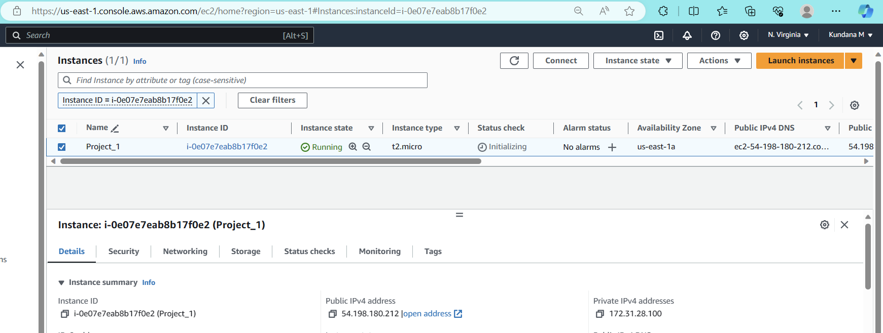

Connect using Putty:

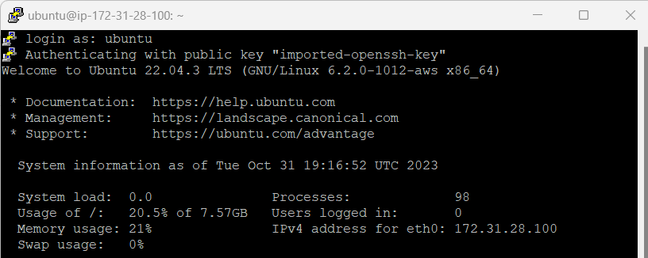

Update your system using the command

***sudo apt-get update***

Then use this command to install Apache2

***sudo apt-get install apache2***

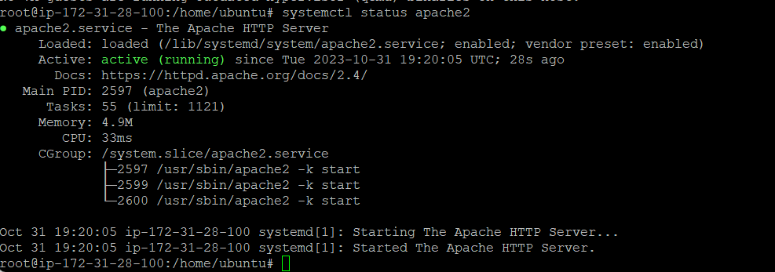

For bringing the file from local system to cloud, as we connected using putty we can open command prompt in windows and give below:

***pscp -i proj_1.ppk "index.php" ubuntu@* 54.198.180.212*:/home/ubuntu***

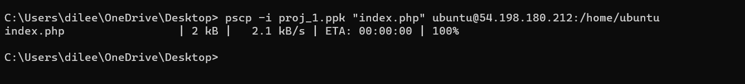

***On ubuntu:***



Remove existing index.html file and add the php index file to var/www/html

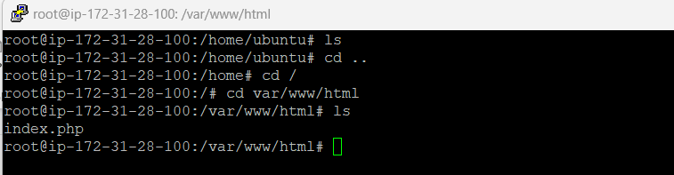

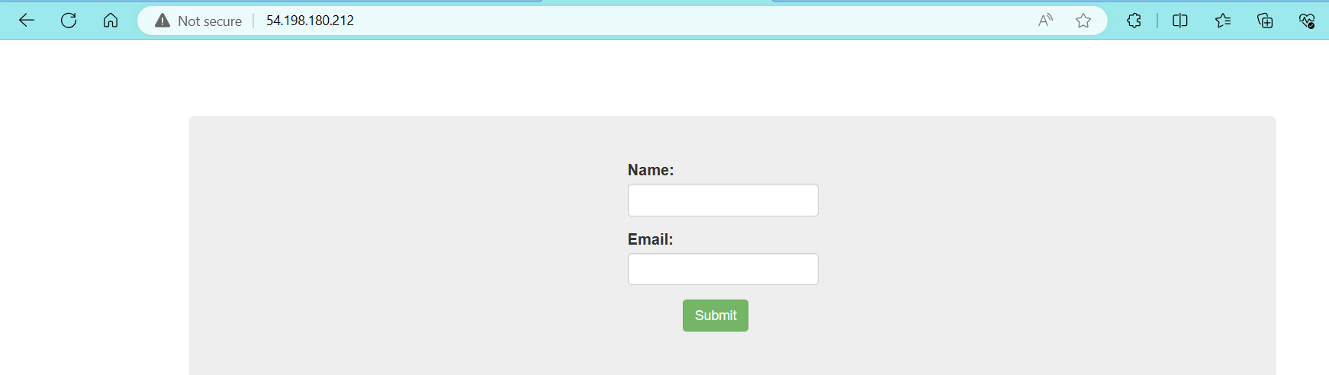

* Then install php-mysql using the following command

***add-apt-repository ppa:ondrej/php***

***apt-get update***

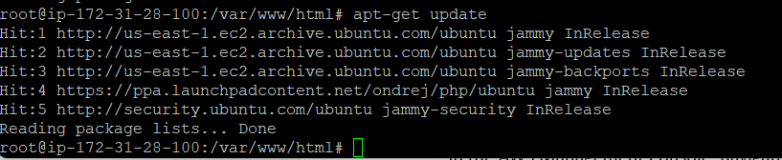

***apt-get install mysql-client -y***

***apt install php5.6 php5.6-mysqli -y***

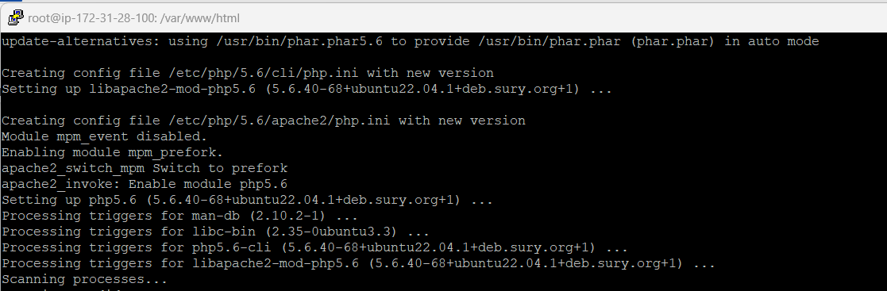

2. Create an RDS Instance:

- In the AWS Management Console, navigate to RDS.

- Launch a new RDS instance (MySQL) with the desired specifications.

- Set the DB instance identifier, master username, and password.

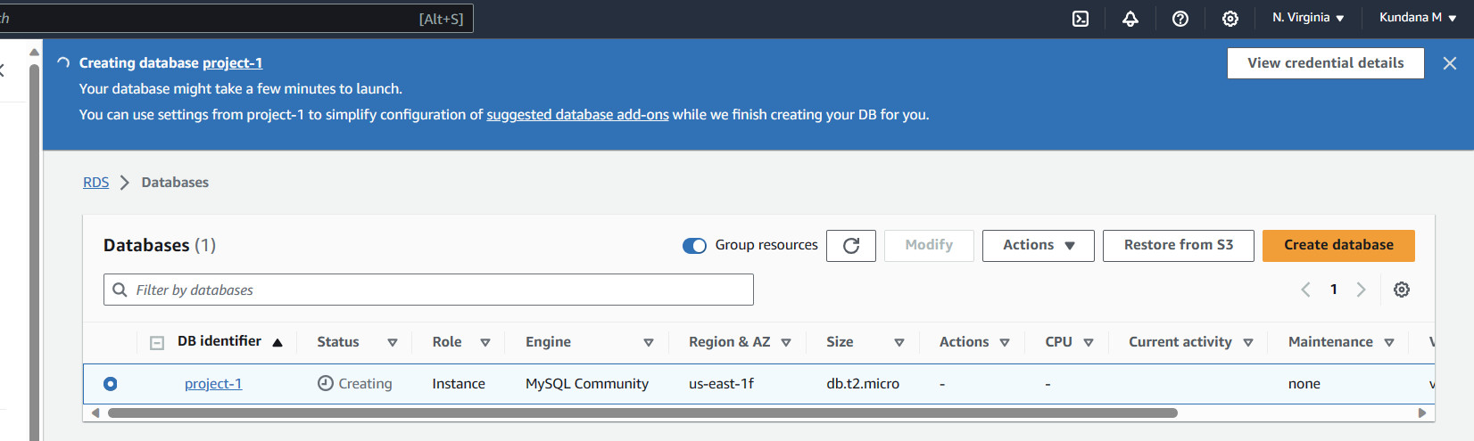

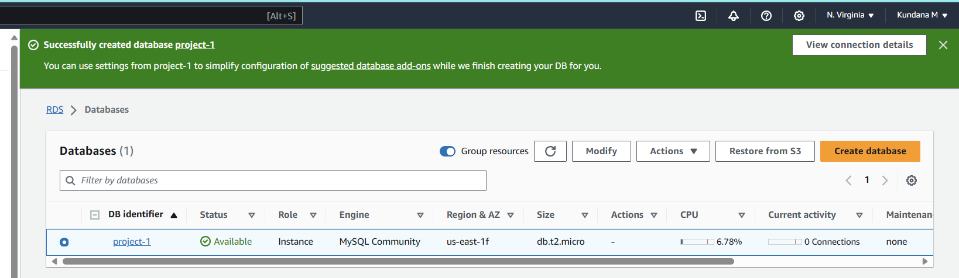

3. Create Database & Table in RDS Instance:

- Connect to the RDS instance using a MySQL client.

***mysql -h project-1.cedw6r3adgfk.us-east-1.rds.amazonaws.com -u admin -p***

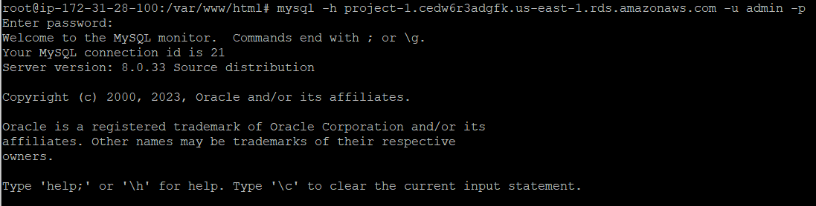

- Create a database named 'intel': `CREATE DATABASE intel;`

- Use the 'intel' database: `USE intel;`

- Create a table named 'data':

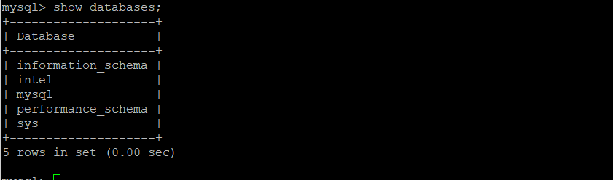

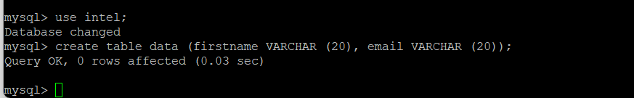

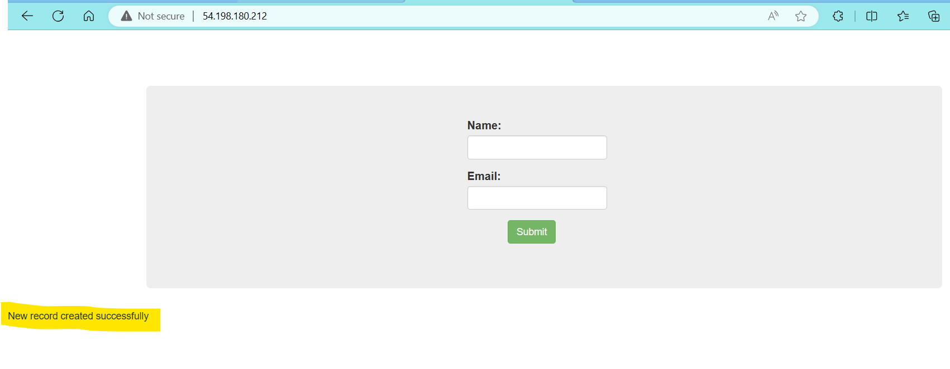

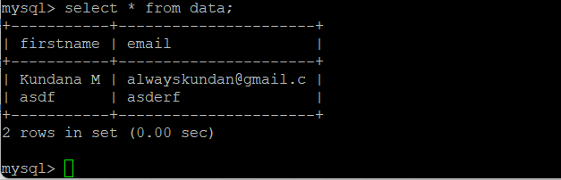

5. Enable Auto Scaling on EC2 Instances:

Create a AMI from existing EC2 instance,

- Set up an Auto Scaling Group.

- create a launch configuration along with load balancer with min 2 capacity



Launch template created for ASG

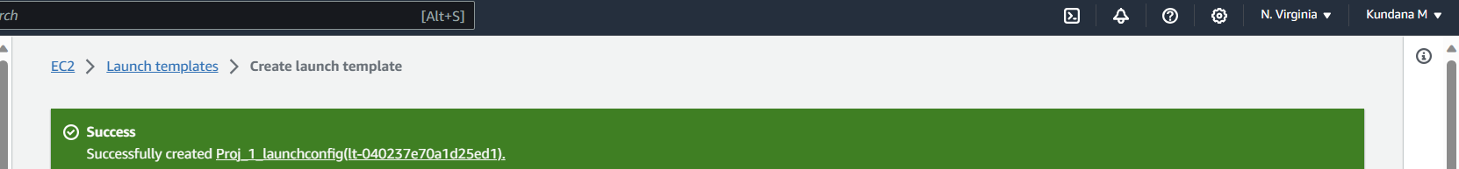

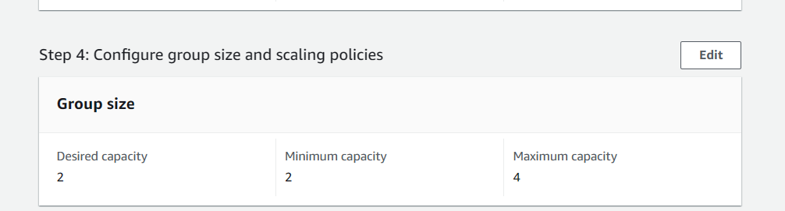

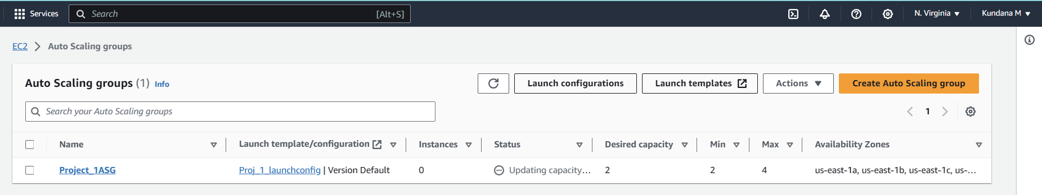

ASG has created 2 new instances:

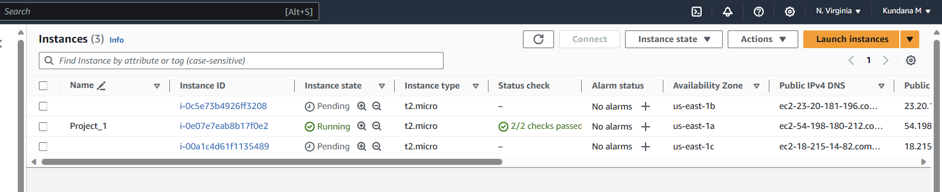

Webserver working from now instance: http://23.20.181.196/

